SQL CAPSTONE PROJECT

WEEK 2

Dataset:

Client 3: Sports Stats (Olympics Dataset - 120 years of data)

SportsStats is a sports analytic company that collaborates with top personal trainers and local news sources to offer their partners "interesting" findings. Insights can be patterns or trends that draw attention to particular people, occasions, nations, etc. in order to create a news article or identify important health insights.

Step 1: Descriptive Statistics On The Dataset

1) First, I looked up the average age, weight, and height of medal winners in each sport. This was done in order to gain a deeper comprehension of the data and details on the optimal body type for every sport.

SQL Query:



Output:

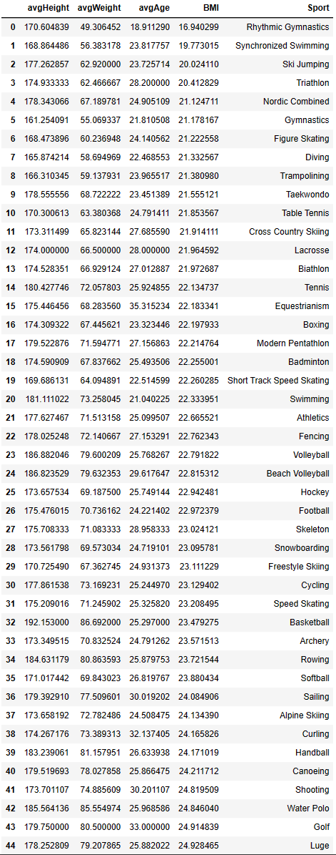

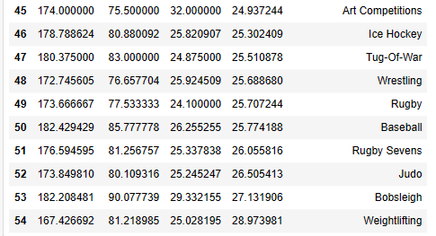

This was the result of that query.

This assisted me in responding to the following queries:

1. The typical weight and height of medal winners in each competition

2. What is the typical age of each game's medal winners?

2) Secondly, I discovered the overall number of medals each nation has earned.



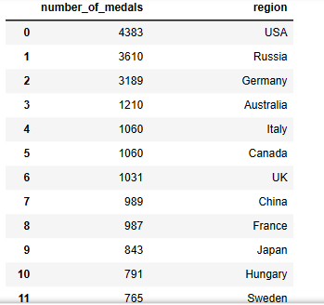

This query helped me understand which countries have won the most medals in the games.

3) Lastly, I discovered which nation has won the greatest number of medals in each game.



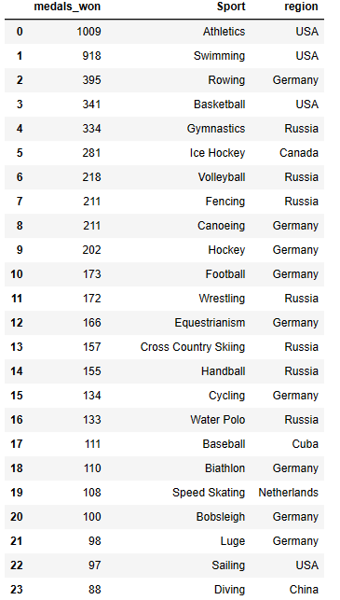

This made it easier for me to determine which nation had won the most medals overall in each competition.

Step 2: Key Points

Key Points Discovered from The Data:

1. Every athlete has an ideal BMI.

2. More medals have been won by developed nations in every sport.

3. Developed nations have routinely taken home more medals overall.

Step 3: Hypothesis Testing

Hypothesis 1:

The medal-winning athletes' average BMI values are in line with the ideal values.

Answer – The majority of this hypothesis proved to be correct. The average BMI for nearly every sport ranged from 18.5 to 24.9.

In contrast, the BMI for gymnastics was below average.

Sports like weightlifting, tug of war, and wrestling have higher percentages than average.

Hypothesis 2:

Richer nations have won more medals in sports because of their advanced sporting infrastructure.

Answer – It also turned out that this theory was correct. Developed nations with a history of success include Russia, Germany, the United States, Australia, Canada, and the United Kingdom.

One possible explanation for this could be that these nations create more and better athletes because they have stronger sports infrastructure.

Step 4: Additional Questions

How have the proportions of different genders participating in each sport changed throughout time?

Has the number of women participating in national sports increased over time?